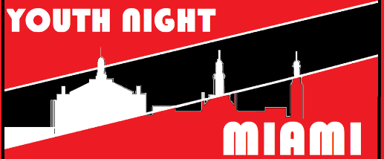
BE AT THE FIRST BAPTIST CHURCH NEW PARIS @ 5PM
Friday – Saturday 29 – 30 March
- HAVE YOU PAID $30.00?
- HAVE YOU FILLED OUT A ROCK WALL WAIVER?
- HAVE YOU COMPLETED A 2019 YOUTH WAIVER at www.fbcnp.com?
Event Time Line:
5pm – Meet at Church 6751 State Route 320 New Paris OH 45347
6:45 pm-8 pm Registration / Open Rec (courts)
8 pm-10 pm Swim / Open Rec
10 pm-12 am Climb / Open Rec / 1 st Snack
12 am-1 am Devotion Courts with Chairs/Mic (All required to attend)
1 am-2:30 am Pizza (open rec when finished eating done)
2:30 am 3v3 Basket Ball Tourney
3:45 am Dodgeball / Open Rec
5 am Breakfast Set Out / Open Rec
6 am Depart for home
7am Arrive Back at church (Parents/Rides plan to meet us back at fbcnp@7AM)
Note: Time slots are a guideline for us and the rec center not a perfect schedule. Please be patient with us if an activity is running shorter or longer than the time allotted on the agenda.
All activities are optional. We strongly encourage youth and leaders to play and participate in the fun. If there’s a reason you would rather not, we aren’t going to make you! However, EVERYONE is required to participate during devotion between 12am-1am time slot!
***FOOD: If you have special dietary needs, you need to communicate with your Youth leader and make arrangements to bring food options that will work for you!
***We recommend getting a good night’s sleep the night before, drinking A LOT of water and eating a good dinner before you set off for the event. We will have options for food throughout the evening, but they will be LATE NIGHT!
Recommended Packing List
DO’s and DON’Ts
DO BRING:
- A Good Attitude
- Your Rock Wall Wavier
- Towel
- Swim clothes that cover up your body. (If you have questions about modesty ask your great
grandma, or give me a call!)
- Anything you need to go from swimming to the rest of the evening
- Gym Clothes to play in
- Athletic Type shoes (please not sandals)
- Water bottle
- A bag to put it all in
- A lock if you want to lock it up in the locker room
- You can bring your favorite Ping Pong Paddle or your own basketball (We will have equipment! You are responsible for these items if you bring them. Put your name on them!!!)
DON’T BRING:
- A BAD ATTITUDE
- SUPER EXPENSIVE STUFF THAT’S GOING TO GET LOST, BROKEN OR STOLEN
- Weapons of any kind. No firearms, cross bows, ninja swords, pocket knives, hand grenades or like items at this event! Sorry.
- Clothing that shows your undergarments while you are wearing it
- Clothing that shows anything your undergarments were invented to cover
- Headphones or earbuds: This is a group event you can jam out to your own tunes at home.

NOTE: There will be NO access to weight rooms or gym equipment during this event.
MORE NOTES: Cell phones or other devices capable of taking pictures or video are NOT allowed in the locker rooms or pool areas during this event! We can work with your youth leaders to secure these items while you change/swim.

HAVE QUESTIONS??? You are welcome to contact me anytime. If I’m not available, I will work to get back with you as soon as I can.
CALL/TEXT: Nate Osborne Cell: 937-336-6135
CALL: First Baptist Church New Paris: 937-437-1171
EMAIL: Nate Osborne: Nathan@fbcnp.com

